

Registration Information and Rules for Participants
- To register FREE in the competition, visit our website @fortligonier.org and look for the “Events” tab. The link will be posted to our website by January 31. Deadline to register is Monday, February 26.
- Participants can work in groups of up to 4 or independently
- One winner will be selected from each of the following age ranges, 9-11, 12-14, 15-17
  - Group participants will be judged according to age of oldest member (High School seniors who recently turned 18 will be accepted for oldest age range)
  - A Child who is 8 years old, but is in 3rd Grade may also participate
- Forts must be transferable in order to be put on display to participate in the competition
- Forts must be no larger than 2 x 2 feet in size
- Forts must resemble an 18th Century (1700s) fortification, participants should NOT seek to replicate Fort Ligonier, but complete their own research for inspiration to create a unique model
- Exact Models of Real Historical Forts will be disqualified from the competition
- Materials can include, but are not limited to popsicle sticks, toothpicks, paper Mache, fabric, Styrofoam, twigs, clay, etc. (be creative!!!).
- Forts must include a typed paragraph long description (5-7 sentences) of the fort including its name and a brief description of everything included
- Fort buildings and any additional structures must be labeled in some way for the audience
- Forts will be judged by a team of three judges from our staff
- Forts judged on the following criteria: description, authenticity, creativity, completeness, neatness (rubric attached to this packet).
- Cash prizes presented to winners!
- Competition will conclude on Saturday, March 9 at 4 PM at Fort Ligonier
  - Models may be dropped off between 2-4 PM Monday-Friday, March 4-8
    - Entries will be accepted no later than 1 PM March 9
  - Winners will be announced at 3 PM in Our Center for History Education
- Admission is free March 9 for participating students, guests will pay reduced $8 admission to the fort
- Deadline to register to compete is Monday, February 26 at 11:30 PM
- Participants may get started as soon as they register!
- email assistant director of education, Dave Swank at dswank@fortligonier.org if you have any further questions


Grading Rubric
Note: Fort Models graded on the following criteria.
Score | Description | Authenticity | Creativity | Completeness | Neatness
5 | This model included an exemplary description of the fort’s name and structures included in 5-7 sentences. Each building labeled separately for the judges’ understanding. | This model used all materials to create a perfect, historically accurate display of an 18th Century fortification without making a replica of a real fort. | This model went beyond expectations by using materials to complete a creative, unique, and thorough model of an 18th Century fortification. | This model was thorough in its completion and exceeded all expectations. They perfectly matched their description. | This model was well organized and met the 2 x 2 feet size requirement. Structures on display demonstrated exemplary neatness with no blemishes or mistakes evident.
4 | This model included a good description of the fort’s name and structures included in 5-7 sentences, and they labeled most of the buildings on display for the judges’ understanding. | This model used most materials to create a historically accurate display of an 18th Century fortification, with only one or two inaccuracies. | This model met expectations by using common craft supplies to create an 18th Century fortification. | This model met expectations and completed all requirements with only one or two incompletions based on their description. | This model was well organized. The structures included were tidy, but evidence of one or two mistakes or blemishes were present on the final display.
3 | This model provided an average description of the fort’s name, but provided little information about the structures included in 5-7 sentences. They did not label most of the buildings on display. | This model used some of their materials to resemble a historically accurate 18th Century fortification. They included three or four inaccuracies. | This model used common materials to create an 18th Century fortification. They met most of the criteria, but could have been more creative with their display. | This model was mostly complete, however it included three or four missing details based on their description. | This model demonstrated average neatness. The structures were put together nicely, but evidence of three or four mistakes or blemishes were present on display.
2 | This model provided a below average description of the fort’s name and additional structures in 5-7 sentences. They did not label any of the buildings on display. | This model provided a below average historically accurate 18 Century fortification. This display included at least five inaccuracies with the materials used. | This model provided a below average creative display. Their fortification closely resembled Fort Ligonier with little to no unique features. | This model provided below average completeness. Five structures were missing details that should have matched up with their description. | This model provided below average neatness. Many structures were broken or falling apart. Evidence of five mistakes were present on display.
1 | This model provided no information about the Fort’s name and structures in 5-7 sentences or less. They did not label any of the buildings on display. | This model did not resemble a historically accurate 18th Century fortification with over 5 inaccuracies included. | This model provided no creativity or unique qualities. They created an exact replica of Fort Ligonier. | This model was incomplete. There were more than five unfinished structures with the details described in the description absent. | This model lacked neatness. The structures were broken or falling apart. There was evidence of over five blemishes or mistakes.
Total Score: ______

Resources for Guidance
Participants are encouraged to do their own research, but the following resources provide information to get started. Remember: Forts must resemble 1700s look!
Images of 18th Century (1700s) Forts:
Fort Ligonier
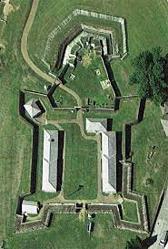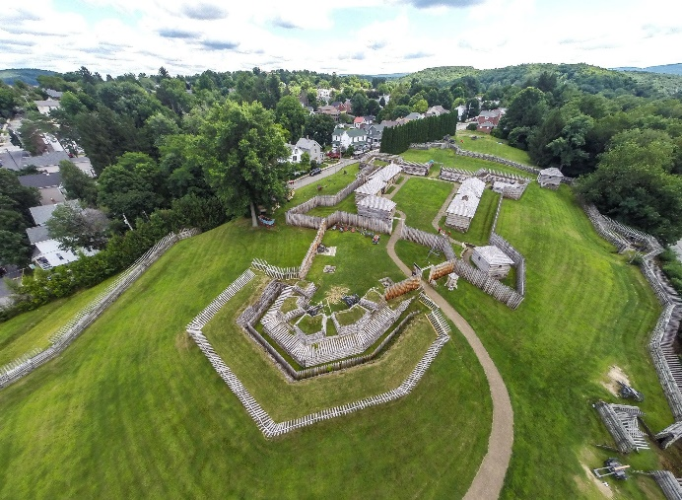
Old Fort Niagara
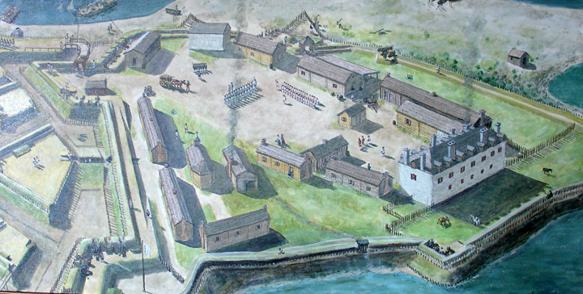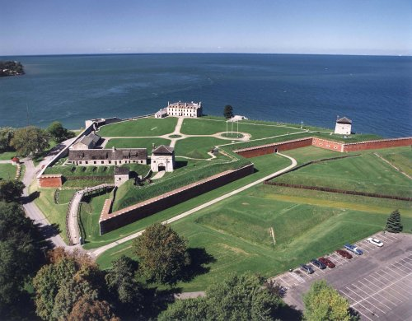
Fort Pitt
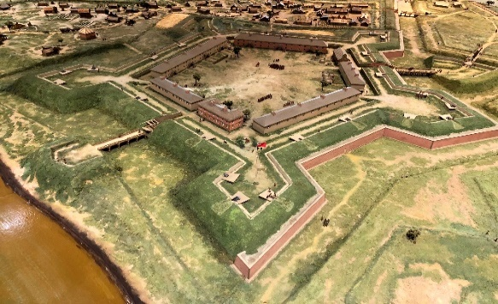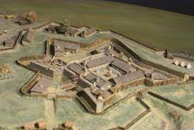
Fort William Henry
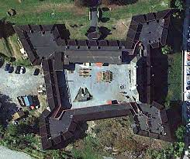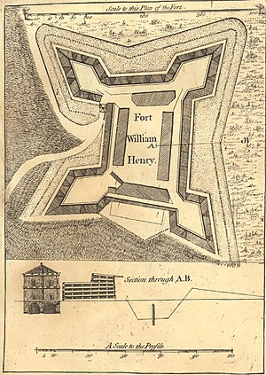

Examples of model forts:
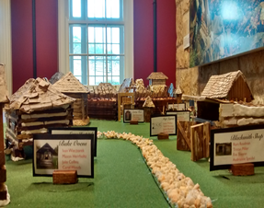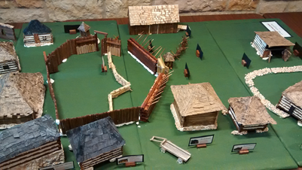
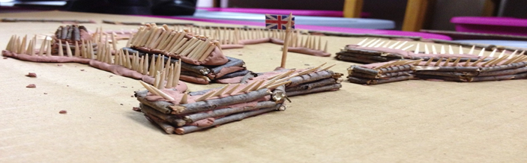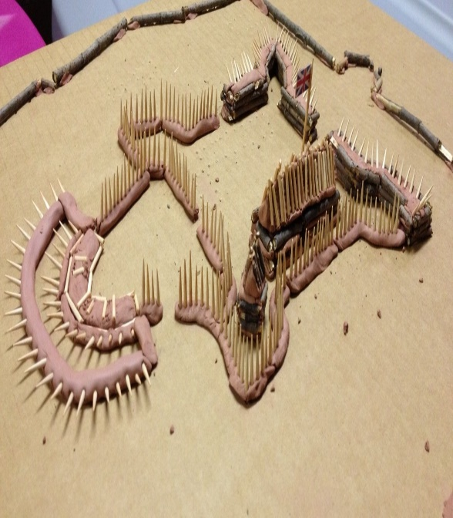

General Historic Information
- Forts in the 1700s were typically named after an important individual or nearby waterway
- could include the following structures:
  - Storehouses: tools and supplies kept here
  - Soldiers Barracks: Place for soldiers to sleep (although many slept in tents)
  - Officer’s Quarters: Place for officers to rest or hold meetings
  - Officer’s mess: Place for officers to dine
  - Quartermaster’s Office: Place for quartermaster to keep track of supplies
  - Powder Magazine: stored gunpowder safely underground
  - Guardhouse: Allowed for guards to rest and rotate guard every two-three hours
  - Hospital Ward: Typically kept away from interior to prevent spread of diseases
- Forts typically had designated cannon batteries to hold artillery of varying sizes for the defense of the fort
- Walls were built at different angles to allow for monitoring the exterior of the fort in all directions (each individual corner is called a bastion)
- Some forts, such as Fort Ligonier, included a dry moat as an extra layer of defense from outside threats
- Forts were ideally built either near water or on higher ground to allow for easier transportation and the ability to monitor ground surrounding the fortification
- Fort walls were mostly made from wood, stone, or sod (earthen works)
- Some forts had different types of structures with varying strength including, but not limited to…
  - Palisade Wall (most basic): Vertically aligned log structures with sharp points on the top resembling “giant toothpicks”
  - Horizontal Log Wall: Horizontally stacked logs interwoven with each other with phrasing (wooden stakes), sticking out of the top.
  - Cribbed Wall (most complex): Double layered horizontal log wall with stone, sod, or soil filling the gaps between each layer (like a crib).
  - Bastion: a structure projecting outward from the curtain wall of a fort, most commonly angular in shape and positioned at the corners of the fort.
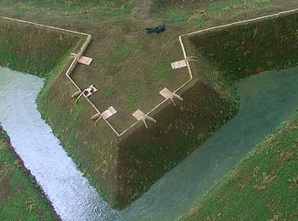
  - Redan: a work in a V-shaped bulge of a fort wall in an angle towards an expected attack. It can be made from earthworks or other material.
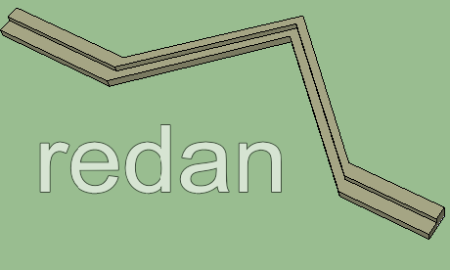
- Additional Links:
  - Fort Ligonier (drone): https://www.youtube.com/watch?v=iQuNnTao1pA

  - Fort Niagara (drone): https://www.youtube.com/watch?v=XShUHh4ZDUU

  - Surveying Information: https://www.youtube.com/watch?v=49IIFXUl1jg

  - Article: https://slate.com/human-interest/2015/01/history-of-fortifications-british-forts-in-the-american-colonies.html

  - Article: https://www.nps.gov/fone/learn/historyculture/fortification-in-the-wilderness-the-defenses-of-fort-necessity.htm

  - Article: https://clements.umich.edu/exhibit/geometry-of-war/case-3/

Description Example

Note: The description below is an example of what the judges will be looking for attached to your models. This example serves as a guide and should NOT be copied. Therefore, your work should be unique! Be sure to include a description of the fort’s name, the buildings included, and any additional information you wish to highlight to set your fort apart from the rest!

Fort GW

The name of this model fort is Fort GW, named after the first leader of our country, George Washington. This model includes a variety of different structures to resemble an 18th Century fortification. The structures include a storehouse, officers’ quarters, cannon battery, and hospital ward. The hospital ward sits in the far corner of the fort to protect against the spread of diseases. The fort’s walls include five bastions and the materials used represent a palisade wall. Along the side of the eastern wall includes a small streambed designated for extra protection from possible threats.

**Be sure to label all buildings or structures separately from the description for the judges to see **

